**2nd Grade Fridge Facts**

**August 22nd–26th**

In writer’s workshop, young authors will learn to plan, draft, revise, edit and publish their Narrative pieces.

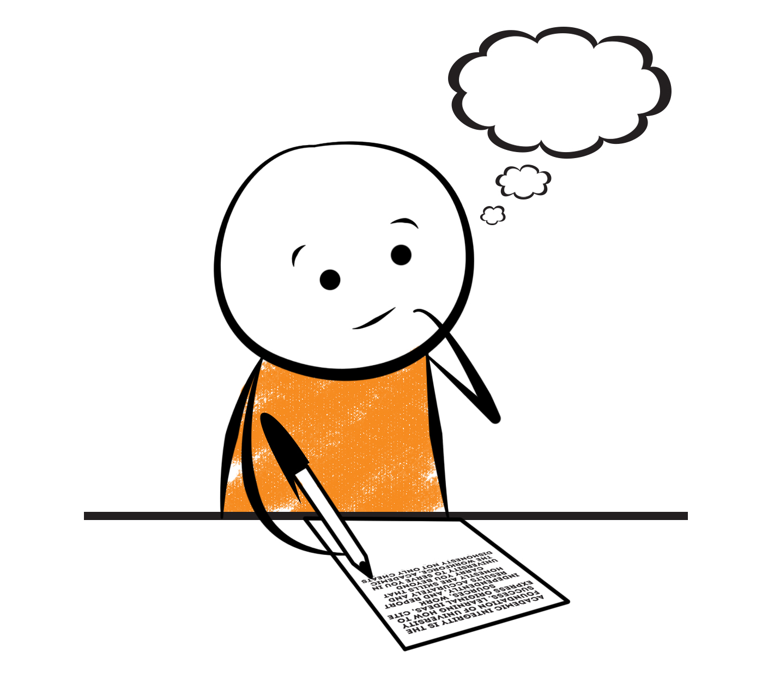

[](http://www.google.com/imgres?imgurl=http://pad2.whstatic.com/images/thumb/4/4b/MNKY07.JPG/300px-MNKY07.JPG&imgrefurl=http://www.wikihow.com/Draw-a-Cartoon-Monkey-Face&usg=__R59DajZ-oRuc0Bs2tqwaCqkeyrc=&h=215&w=300&sz=13&hl=en&start=47&zoom=1&tbnid=lFt_dXax-slmVM:&tbnh=121&tbnw=160&ei=ULAwTcbrL8H78AbdsYTQCA&prev=/images?q=cute+cartoon+monkey&um=1&hl=en&rlz=1T4GGHP_enUS412US412&biw=1259&bih=564&tbs=isch:1&um=1&itbs=1&iact=hc&vpx=260&vpy=172&dur=765&hovh=172&hovw=240&tx=97&ty=88&oei=RbAwTZWMM8WxtAar4aiHCg&esq=3&page=3&ndsp=22&ved=1t:429,r:16,s:47)



[](http://www.google.com/imgres?imgurl=http://see.edmonson.k12.ky.us/index_files/StudyislandRibbon.gif&imgrefurl=http://www.millstone.k12.nj.us/teachers/millerj/index.htm&usg=__kVi5j8TDMQias-or_zRD46GlXUQ=&h=366&w=251&sz=11&hl=en&start=7&zoom=1&tbnid=CdoraXaINdFg6M:&tbnh=122&tbnw=84&ei=FamGTdn6B-ay0QHJkfzjCA&prev=/images?q=study+island&um=1&hl=en&rlz=1T4GGHP_enUS412US412&biw=1259&bih=564&tbs=isch:1&um=1&itbs=1)9th

Social Studies

Regions of GA

Science

**Life Cycles**

**Important Reminders**

*Please check your child’s agenda each night and initial.

. * Please place money sent in for lunch, afterschool, etc.

in an envelope labeled with your child’s name, grade,

homeroom teacher’s name, amount of money and

its purpose.

*School starts promptly at 7:45. Please make sure your

child is on time. Your child may be dropped off as

early as 7:10.

*If your child has a change in transportation, please

send his/her teacher a note.

*August 30th at 5:00 is J.E.S. Zaxby’s Night. Come out & join us for food, fun, & help raise money for our school.

*September 1st 6:00 Curriculum Night

|  |  |
| --- | --- |
|  |  |
|  | |

**Reading**

On Tuesday, we will begin reading “Pinky & Rex” by James Howe. We will continue to concentrate on comprehension, fluency and increasing our knowledge of text structure.

**Tuesday, August 23**

Comprehension Test on “Henry and Mudge The First Book” (L.2)

**Monday, August 22**

Spelling/Vocabulary Test with Lesson 2 words

Our lunchtime is at 11:57. You are welcome to

matter.

M

**Group 2 Spelling Words (L.3) “Pinky & Rex”**

trash trace harden

stand star surface

stamp park market

face shark jealous

place remark impress

**2nd Grade Teacher’s**

**Contact Information**

E-mail:

kellybryson@.pickenscountyschools.org

darlenecrenshaw@.pickenscountyschools.org

[tonyadobson@.pickenscountyschools.org](mailto:tonyadobson@.pickenscountyschools.org)

[lizpatrick@.pickenscountyschools.org](mailto:lizpatrick@.pickenscountyschools.org)

[teresaroper@.pickenscountyschools.org](mailto:teresaroper@.pickenscountyschools.org)

**Phone**:

706-253-1730

School Webpage:

<http://jasperele.pickens.k12.ga.us/>

(You will find links on the school’s webpage to all of the second grade teachers’ webpages.)

**Math**

We will continue extending our knowledge of place value. Students will need to understand that the three digits of a three-digit number represent amounts of hundreds, tens, & ones; (e.g., 706 equals 7 hundreds, 0 tens, and 6 ones). In addition, students will need to count within 1000; skip count by 5s, 10s, & 100s. You can help at home by quizzing your child daily with addition & subtraction flash cards because they will need to be able to fluently add and subtract within 20 using mental strategies. By the end of Grade 2, students should know from memory all sums of two one-digit numbers.



**V**

**Vocabulary Words (L.3) “Pinky & Rex”**

**jealous-** an adjective used for the feeling that you get when you are angry or sad because you want what another person has, or you want more attention.

**impress-**a verb for what you do when you really influence someone’s thoughts or feelings in a good way.

**irritate-** a verb that means to anger or annoy someone.

**selfish-** an adjective that means thinking only of what you want.

**distracted-** an adjective that means not thinking about what you should be thinking about.

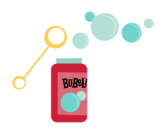 ou

**Group 1 Spelling Words (L.3) “Pinky & Rex”**

trash trace bark

stand star

stamp park

face shark

place pace