In writer’s workshop, students will plan, draft, & organize. We will continue to focus on the Narrative genre & writing & elaborating with detail.

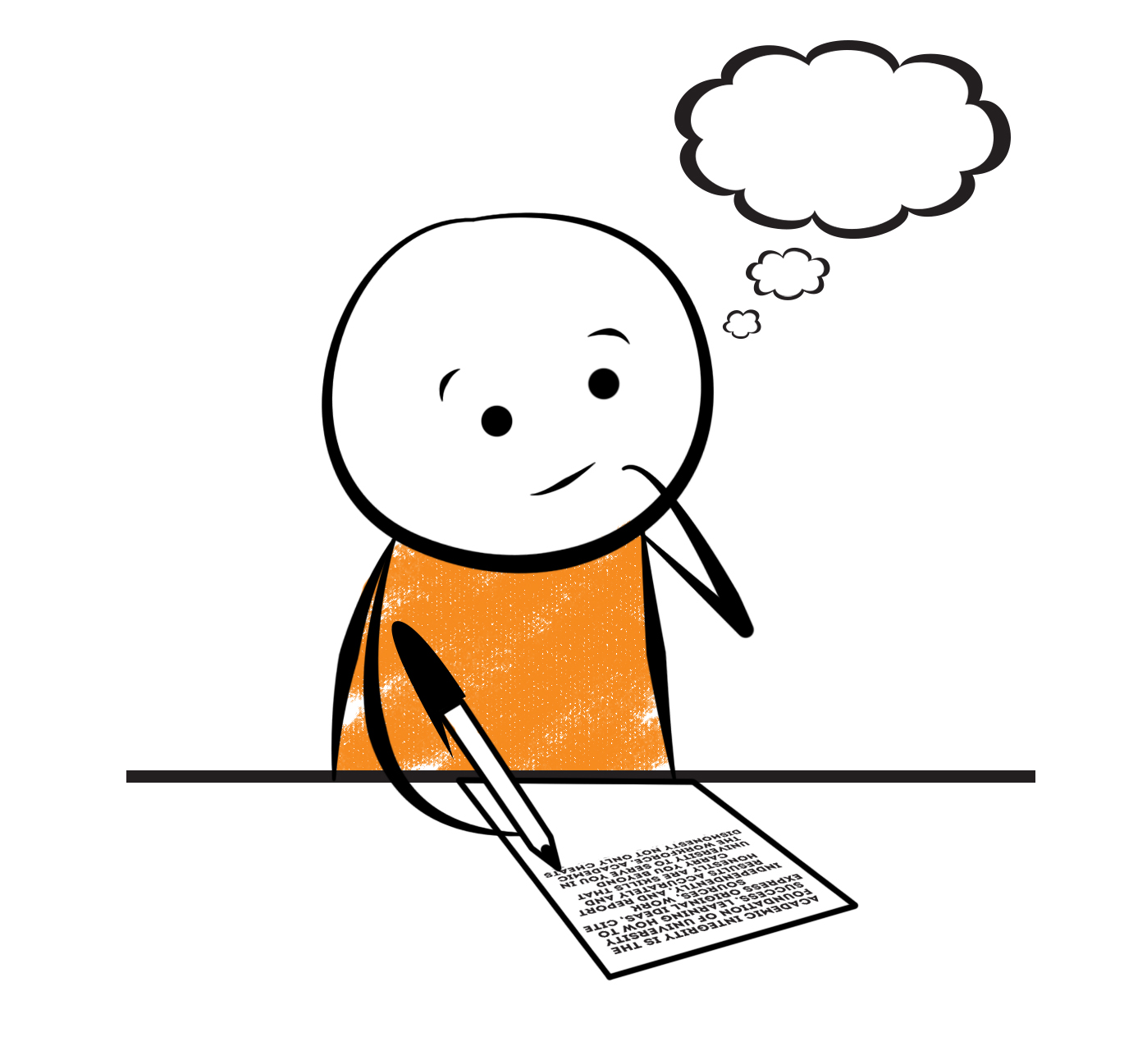

**2nd Grade Fridge Facts**

**Nov. 1st – Nov. 5th**

[](http://www.google.com/imgres?imgurl=http://pad2.whstatic.com/images/thumb/4/4b/MNKY07.JPG/300px-MNKY07.JPG&imgrefurl=http://www.wikihow.com/Draw-a-Cartoon-Monkey-Face&usg=__R59DajZ-oRuc0Bs2tqwaCqkeyrc=&h=215&w=300&sz=13&hl=en&start=47&zoom=1&tbnid=lFt_dXax-slmVM:&tbnh=121&tbnw=160&ei=ULAwTcbrL8H78AbdsYTQCA&prev=/images?q=cute+cartoon+monkey&um=1&hl=en&rlz=1T4GGHP_enUS412US412&biw=1259&bih=564&tbs=isch:1&um=1&itbs=1&iact=hc&vpx=260&vpy=172&dur=765&hovh=172&hovw=240&tx=97&ty=88&oei=RbAwTZWMM8WxtAar4aiHCg&esq=3&page=3&ndsp=22&ved=1t:429,r:16,s:47)

Science

**Cross Curricular: Migration of the Monarch Butterfly**

Social Studies

Creek and Cherokee Indians

**.**

[](http://www.google.com/imgres?imgurl=http://see.edmonson.k12.ky.us/index_files/StudyislandRibbon.gif&imgrefurl=http://www.millstone.k12.nj.us/teachers/millerj/index.htm&usg=__kVi5j8TDMQias-or_zRD46GlXUQ=&h=366&w=251&sz=11&hl=en&start=7&zoom=1&tbnid=CdoraXaINdFg6M:&tbnh=122&tbnw=84&ei=FamGTdn6B-ay0QHJkfzjCA&prev=/images?q=study+island&um=1&hl=en&rlz=1T4GGHP_enUS412US412&biw=1259&bih=564&tbs=isch:1&um=1&itbs=1)9th

**Important Reminders**

* Please check your child’s agenda each night and initial.

. * Please place money sent in for lunch, afterschool, etc.

in an envelope labeled with your child’s name, grade,

homeroom teacher’s name, amount of money & purpose.

*School starts promptly at 7:45. Please make sure your

child is on time. Your child may be dropped off as

early as 7:10.

* If your child has a change in transportation, please

send his/her teacher a note.

* October 28 – Fall Carnival (6 pm – 8 pm)

* October 31 – All pictures and/or money is due by this day!

* November 1 – Santa Pictures (prepaid); Fire Safety Program

* November 6 – Daylight Saving Time ends (set clocks back an hour)

* November 8 – Election Day / In-service (No School for students)

* November 9 – Progress Reports; Fundraiser Game Truck

* November 10 – Thanksgiving Lunch

* November 11 – Veterans Day / Veterans Day Parade

|  |  |
| --- | --- |
|  |  |
|  | |

**Reading**

We will continue reading “The Journey of a Butterfly” **(L.8)** by Carolyn Scarce. We will concentrate on comprehension, fluency, vocabulary, & increasing our knowledge of text structure (cycle).

**Thursday, November 4**

Comprehension Test on “The Journey of a Butterfly” **(L.8)**

**Wednesday, November 3**

Spelling/Vocabulary Test with **Lesson 8** words

Our lunchtime is at 11:57. You are welcome to

matter.

M

**Group 2 Spelling Words (L.8) “The Journey of a Butterfly”**

eggs feed creature

rest asleep sincere

reach trees

leaves greeting

eat dreaming

**Math**

We will continue to focus our attention on several prerequisite skills for multiplication including solving repeated addition number sentences, skip counting, and building arrays. Repeated addition and skip counting are useful for adding and counting equal groups, but they are the building blocks for skills that children will later use in multiplication. Students will create arrays to solve repeated addition number sentences.



**2nd Grade Teachers’**

**Contact Information**

E-mail:

kellybryson@.pickenscountyschools.org

darlenecrenshaw@.pickenscountyschools.org

[tonyadobson@.pickenscountyschools.org](mailto:tonyadobson@.pickenscountyschools.org)

[lizpatrick@.pickenscountyschools.org](mailto:lizpatrick@.pickenscountyschools.org)

[teresaroper@.pickenscountyschools.org](mailto:teresaroper@.pickenscountyschools.org)

**Phone**:

706-253-1730

School Webpage:

<http://jasperele.pickens.k12.ga.us/>

(You will find links on the school’s webpage to all of the second grade teachers’ webpages.)

**Vocabulary Words (L.8) “The Journey of a Butterfly”**

**migration** – a type of travel where animals move long distances to avoid winter weather. Whales, geese, and monarch butterflies migrate.

**monarch** – a large, deep-orange butterfly having black and white markings, the larvae feed on the leaves of milkweed.

**return** – to come back to the same place.

**season** – one of the four periods of the year (spring, summer, fall, winter) characterized by particular conditions of weather and temperature. Butterflies behave differently in each season.

 ou

**Group 1 Spelling Words (L.8)**

**“The Journey of a Butterfly”**

eggs feed

rest asleep

reach trees

leaves greeting

eat dreaming