In writer’s workshop, students will plan, draft, & organize. We will continue to focus on the Narrative genre & writing & elaborating with detail.

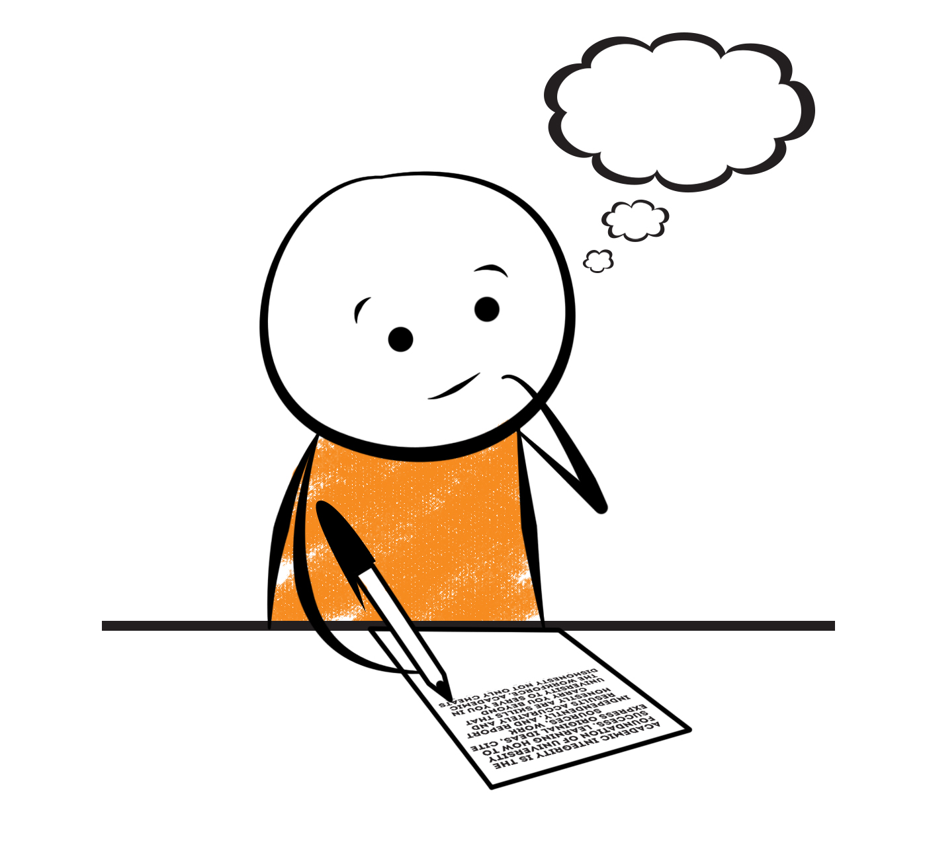

**2nd Grade Fridge Facts**

**Nov. 28th – Dec. 2nd**

[](http://www.google.com/imgres?imgurl=http://pad2.whstatic.com/images/thumb/4/4b/MNKY07.JPG/300px-MNKY07.JPG&imgrefurl=http://www.wikihow.com/Draw-a-Cartoon-Monkey-Face&usg=__R59DajZ-oRuc0Bs2tqwaCqkeyrc=&h=215&w=300&sz=13&hl=en&start=47&zoom=1&tbnid=lFt_dXax-slmVM:&tbnh=121&tbnw=160&ei=ULAwTcbrL8H78AbdsYTQCA&prev=/images?q=cute+cartoon+monkey&um=1&hl=en&rlz=1T4GGHP_enUS412US412&biw=1259&bih=564&tbs=isch:1&um=1&itbs=1&iact=hc&vpx=260&vpy=172&dur=765&hovh=172&hovw=240&tx=97&ty=88&oei=RbAwTZWMM8WxtAar4aiHCg&esq=3&page=3&ndsp=22&ved=1t:429,r:16,s:47)

Science

States of Matter

Social Studies

Creek and Cherokee Indians

**.**

[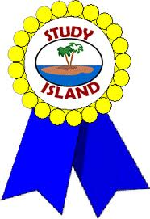](http://www.google.com/imgres?imgurl=http://see.edmonson.k12.ky.us/index_files/StudyislandRibbon.gif&imgrefurl=http://www.millstone.k12.nj.us/teachers/millerj/index.htm&usg=__kVi5j8TDMQias-or_zRD46GlXUQ=&h=366&w=251&sz=11&hl=en&start=7&zoom=1&tbnid=CdoraXaINdFg6M:&tbnh=122&tbnw=84&ei=FamGTdn6B-ay0QHJkfzjCA&prev=/images?q=study+island&um=1&hl=en&rlz=1T4GGHP_enUS412US412&biw=1259&bih=564&tbs=isch:1&um=1&itbs=1)9th

**Important Reminders**

* Please check your child’s agenda each night and initial.

. * Please place money sent in for lunch, afterschool, etc.

in an envelope labeled with your child’s name, grade,

homeroom teacher’s name, amount of money & purpose.

*School starts promptly at 7:45. Please make sure your

child is on time. Your child may be dropped off as

early as 7:10.

* If your child has a change in transportation, please

send his/her teacher a note.

* November 21 – 25 – Thanksgiving Holidays

* December 3 – Fatz Breakfast with Santa (8 – 10 am)

* December 5 – 9 – Winter Wonderland Store

* December 16 – Classroom Christmas Parties (1:30-2:30 pm)

* December 19 – January 2 – Christmas Holidays

* January 6 – 2nd Nine Weeks Awards Assembly; Report Cards

|  |  |
| --- | --- |
|  |  |
|  | |

**Reading**

We will begin reading “The Kidnapped King” **(L.9)** by Ron Roy when we return from the break. We will concentrate on comprehension, fluency, vocabulary, and increasing our knowledge of conflict and resolution within the plot of a story.

**Wednesday, December 14**

Comprehension Test on “The Kidnapped King” **(L.9)**

**Monday, December 5**

Spelling/Vocabulary Test with **Lesson 9** words

Our lunchtime is at 11:57. You are welcome to

matter.

M

**Group 2 Spelling Words (L.9) “The Kidnapped King”**

felt creep yeast

shelter steep neat

spread beet kneed

dead feast leaven

head beast mislead

**Math**

We will begin focusing our attention on using mental math as a strategy to solve subtraction problems. We will work on fluently adding and subtracting within 100 using mental strategies such as place value, properties of operations, and/or the relationship between addition and subtraction. Students will subtract tens and ones, find parts of 100 (ex. 72+__= 100), subtract on a hundred chart, and subtract multiples of 10. Please continue to practice those basic addition and subtraction facts at home.



**2nd Grade Teachers’**

**Contact Information**

E-mail:

kellybryson@.pickenscountyschools.org

darlenecrenshaw@.pickenscountyschools.org

[tonyadobson@.pickenscountyschools.org](mailto:tonyadobson@.pickenscountyschools.org)

[lizpatrick@.pickenscountyschools.org](mailto:lizpatrick@.pickenscountyschools.org)

[teresaroper@.pickenscountyschools.org](mailto:teresaroper@.pickenscountyschools.org)

**Phone**:

706-253-1730

School Webpage:

<http://jasperele.pickens.k12.ga.us/>

(You will find links on the school’s webpage to all of the second grade teachers’ webpages.)

**Vocabulary Words (L.9) “The Kidnapped King”**

**culture** – is a noun that means the set of customs or habits of a group of people who live near one another.

**prince** – a noun that means a boy who will become king some day when his father dies. In some countries, like England, there is a king or queen, and their son is called a prince.

**kaleidoscope** – a noun that means a toy tube filled with glass that can move. You look through one end and see colored reflections from the glass.

**react** – a verb that means to act differently.

 ou

**Group 1 Spelling Words (L.9)**

**“The Kidnapped King”**

felt creep yeast

shelter steep neat

spread beet

dead feast

head beast