In writer’s workshop, students will plan, draft, & organize. We will focus on the Narrative genre & writing with detail.

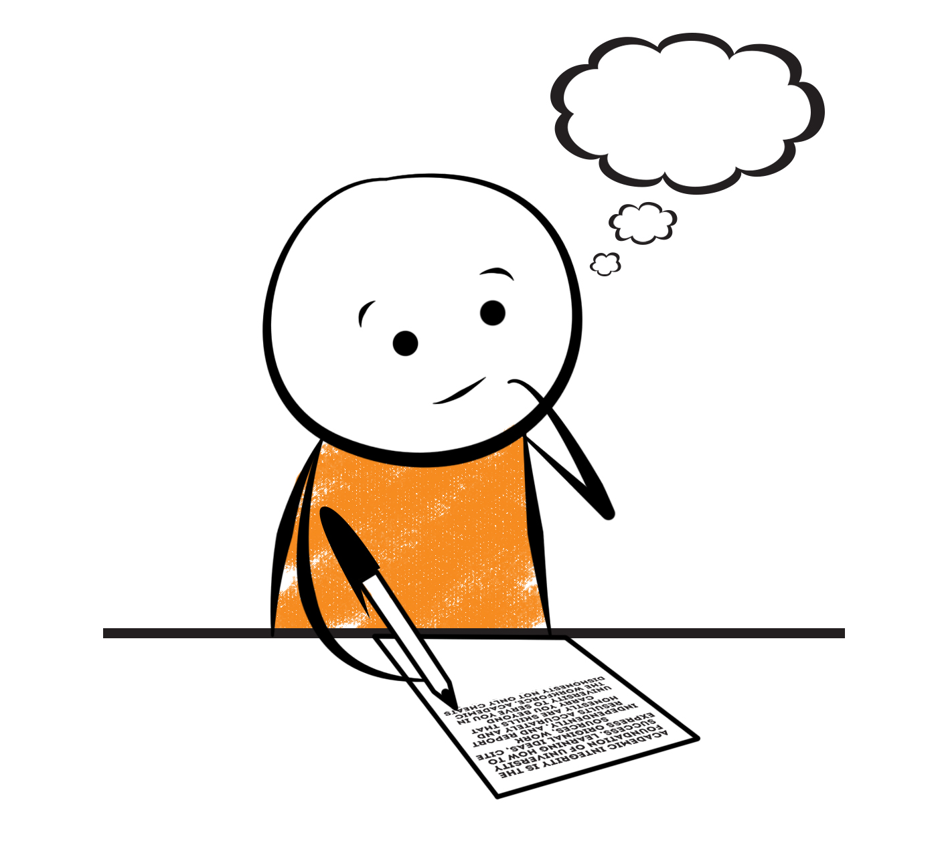

**2nd Grade Fridge Facts**

**Sept. 26th – Sept.30th**

[](http://www.google.com/imgres?imgurl=http://pad2.whstatic.com/images/thumb/4/4b/MNKY07.JPG/300px-MNKY07.JPG&imgrefurl=http://www.wikihow.com/Draw-a-Cartoon-Monkey-Face&usg=__R59DajZ-oRuc0Bs2tqwaCqkeyrc=&h=215&w=300&sz=13&hl=en&start=47&zoom=1&tbnid=lFt_dXax-slmVM:&tbnh=121&tbnw=160&ei=ULAwTcbrL8H78AbdsYTQCA&prev=/images?q=cute+cartoon+monkey&um=1&hl=en&rlz=1T4GGHP_enUS412US412&biw=1259&bih=564&tbs=isch:1&um=1&itbs=1&iact=hc&vpx=260&vpy=172&dur=765&hovh=172&hovw=240&tx=97&ty=88&oei=RbAwTZWMM8WxtAar4aiHCg&esq=3&page=3&ndsp=22&ved=1t:429,r:16,s:47)

Science

**Cross-Curricular: Tale of a Tadpole**

Social Studies

Mary Musgrove

**.**

[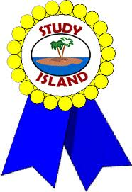](http://www.google.com/imgres?imgurl=http://see.edmonson.k12.ky.us/index_files/StudyislandRibbon.gif&imgrefurl=http://www.millstone.k12.nj.us/teachers/millerj/index.htm&usg=__kVi5j8TDMQias-or_zRD46GlXUQ=&h=366&w=251&sz=11&hl=en&start=7&zoom=1&tbnid=CdoraXaINdFg6M:&tbnh=122&tbnw=84&ei=FamGTdn6B-ay0QHJkfzjCA&prev=/images?q=study+island&um=1&hl=en&rlz=1T4GGHP_enUS412US412&biw=1259&bih=564&tbs=isch:1&um=1&itbs=1)9th

**Important Reminders**

* Please check your child’s agenda each night and initial.

. * Please place money sent in for lunch, afterschool, etc.

in an envelope labeled with your child’s name, grade,

homeroom teacher’s name, amount of money & purpose.

*School starts promptly at 7:45. Please make sure your

child is on time. Your child may be dropped off as

early as 7:10.

* If your child has a change in transportation, please

send his/her teacher a note.

* September 19th – 23rd – Fall Break (No School)

* September 28th – Picture Day

* October 3 – 7 – Book Fair

* October 7 – End of the 1st Nine Weeks

* October 14 – 1st Nine Weeks Awards Day (8:00 am – 8:45 am)

* October 14 – Report Cards

|  |  |
| --- | --- |
|  |  |
|  | |

**Reading**

We will begin reading “Tale of a Tadpole” by Karen Wallace. We will concentrate on comprehension, fluency, vocabulary, and increasing our knowledge of text structure.

**Tuesday, October 4**

Comprehension Test on “Tale of a Tadpole” (L.5)

**Monday, October 3**

Spelling/Vocabulary Test with Lesson 5 words

Our lunchtime is at 11:57. You are welcome to

matter.

M

**Group 2 Spelling Words (L.5) “Tale of a Tadpole”**

horse hurt surface

sport perch merchant

harm fern plural

park bird mural

spurt dirt

**Math**

Our main focus is still on understanding addition & subtraction. Students will continue to use addition strategies such as doubles facts, or making ten as well as subtraction strategies such as “thinking addition” to subtract. Students will continue to write number sentences & solve story problems using a variety of addition & subtraction strategies. Please continue to help at home by quizzing your child with addition & subtraction flash cards because they will need to be able to fluently add and subtract within 20 using mental strategies.



**2nd Grade Teacher’s**

**Contact Information**

E-mail:

kellybryson@.pickenscountyschools.org

darlenecrenshaw@.pickenscountyschools.org

[tonyadobson@.pickenscountyschools.org](mailto:tonyadobson@.pickenscountyschools.org)

[lizpatrick@.pickenscountyschools.org](mailto:lizpatrick@.pickenscountyschools.org)

[teresaroper@.pickenscountyschools.org](mailto:teresaroper@.pickenscountyschools.org)

**Phone**:

706-253-1730

School Webpage:

<http://jasperele.pickens.k12.ga.us/>

(You will find links on the school’s webpage to all of the second grade teachers’ webpages.)

**Vocabulary Words (L.5) “Tale of a Tadpole”**

**amphibian-** a type of animal; lay a special kind of egg without a hard shell; have four legs and are cold blooded.

**tadpole-** a frog that is not fully grown. (egg-tadpole)

**predator-** is the animal(s) that eat other animals.

**prey-** is the animal(s) that a predator eats. Tadpoles are prey because other animals want to eat them.

**competition-** is part of the life cycle of animals. When you are in competition, you have the same goal as someone else. Animals are always in competition for food.

 ou

**Group 1 Spelling Words (L.5) “Tale of a Tadpole”**

horse hurt

sport perch

harm fern

park bird

spurt dirt