In writer’s workshop, students will plan, draft, & organize. We will continue to focus on the Narrative genre & writing & elaborating with detail.

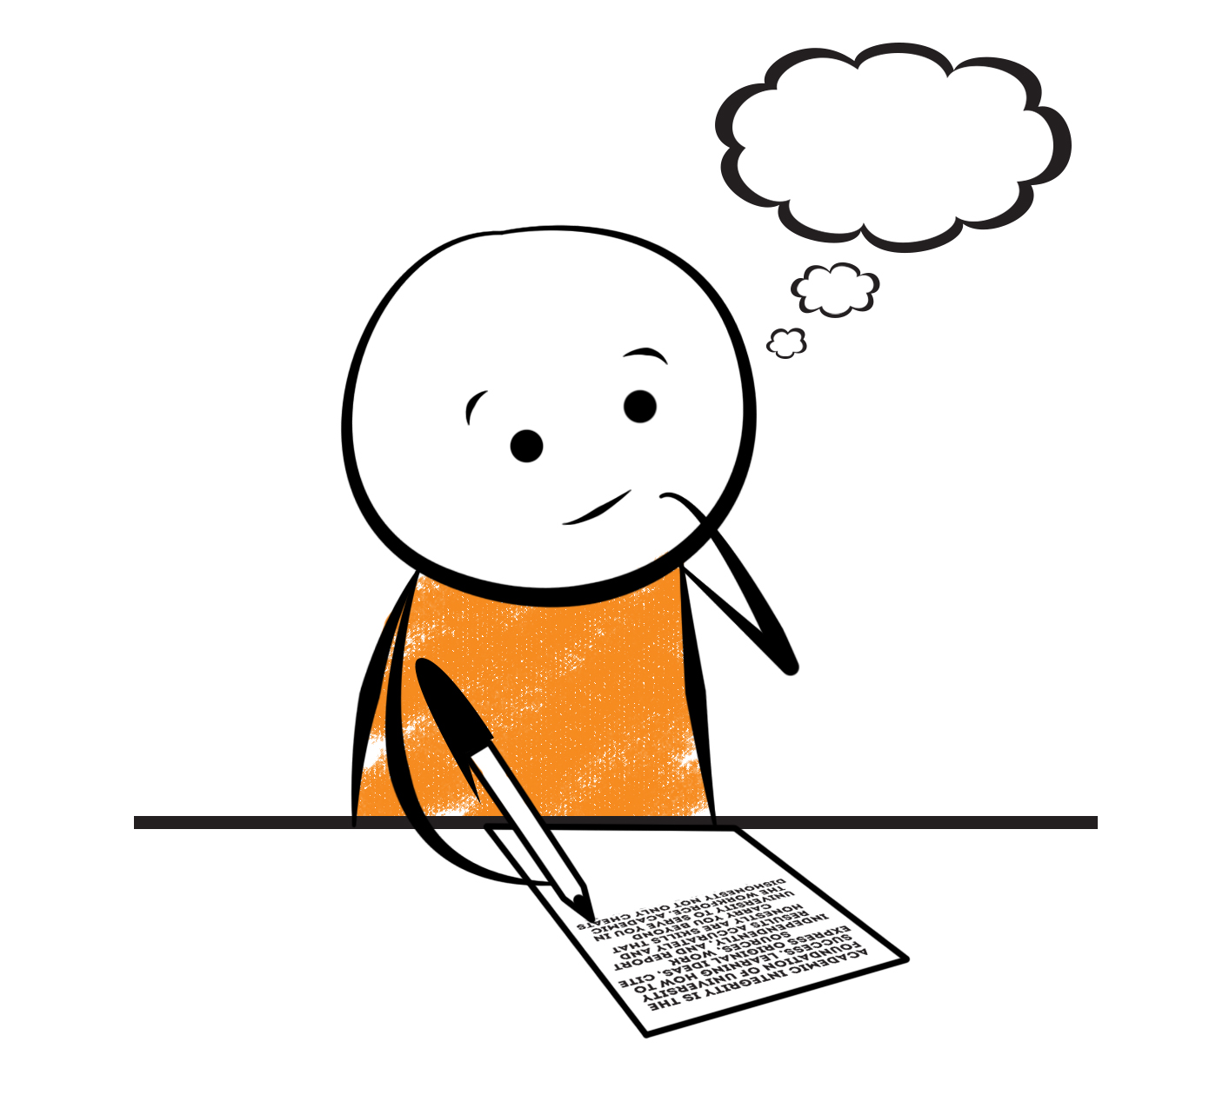

**2nd Grade Fridge Facts**

**Oct. 17th – Oct. 21st**

[](http://www.google.com/imgres?imgurl=http://pad2.whstatic.com/images/thumb/4/4b/MNKY07.JPG/300px-MNKY07.JPG&imgrefurl=http://www.wikihow.com/Draw-a-Cartoon-Monkey-Face&usg=__R59DajZ-oRuc0Bs2tqwaCqkeyrc=&h=215&w=300&sz=13&hl=en&start=47&zoom=1&tbnid=lFt_dXax-slmVM:&tbnh=121&tbnw=160&ei=ULAwTcbrL8H78AbdsYTQCA&prev=/images?q=cute+cartoon+monkey&um=1&hl=en&rlz=1T4GGHP_enUS412US412&biw=1259&bih=564&tbs=isch:1&um=1&itbs=1&iact=hc&vpx=260&vpy=172&dur=765&hovh=172&hovw=240&tx=97&ty=88&oei=RbAwTZWMM8WxtAar4aiHCg&esq=3&page=3&ndsp=22&ved=1t:429,r:16,s:47)

Science

**Cross-Curricular: From Caterpillar to Butterfly**

Social Studies

GA History

**.**

[](http://www.google.com/imgres?imgurl=http://see.edmonson.k12.ky.us/index_files/StudyislandRibbon.gif&imgrefurl=http://www.millstone.k12.nj.us/teachers/millerj/index.htm&usg=__kVi5j8TDMQias-or_zRD46GlXUQ=&h=366&w=251&sz=11&hl=en&start=7&zoom=1&tbnid=CdoraXaINdFg6M:&tbnh=122&tbnw=84&ei=FamGTdn6B-ay0QHJkfzjCA&prev=/images?q=study+island&um=1&hl=en&rlz=1T4GGHP_enUS412US412&biw=1259&bih=564&tbs=isch:1&um=1&itbs=1)9th

**Important Reminders**

* Please check your child’s agenda each night and initial.

. * Please place money sent in for lunch, afterschool, etc.

in an envelope labeled with your child’s name, grade,

homeroom teacher’s name, amount of money & purpose.

*School starts promptly at 7:45. Please make sure your

child is on time. Your child may be dropped off as

early as 7:10.

* If your child has a change in transportation, please

send his/her teacher a note.

* October 17 – School Bus Driver Appreciation Day

* October 24 – 28 – Red Ribbon Week

* October 28 – Fall Carnival (6 pm – 8 pm)

* November 1 – Santa Pictures

* November 6 – Daylight Saving Time ends (set clocks back an hour)

* November 8 – Election Day / In-service (No School for students)

|  |  |
| --- | --- |
|  |  |
|  | |

**Reading**

We will begin reading “From Caterpillar to Butterfly” **(L.7)** by Dr. Gerald Legg. We will concentrate on comprehension, fluency, vocabulary, & increasing our knowledge of text structure (cycle).

**Tuesday, October 25**

Comprehension Test on “From Caterpillar to Butterfly”

**Monday, October 24**

Spelling/Vocabulary Test with **Lesson 7** words

Our lunchtime is at 11:57. You are welcome to

matter.

M

**Group 2 Spelling Words (L.7) “From Caterpillar to Butterfly”**

crack lay mailman

spam hail hailstorm

land drain grateful

mate snail relay

pay grace

**Math**

We will continue to focus on understanding subtraction. Students will continue to use subtraction strategies such as “think addition” to subtract doubles and making 10 to subtract. Students will continue to write number sentences & solve story problems using a variety of addition & subtraction strategies.



**2nd Grade Teachers’**

**Contact Information**

E-mail:

kellybryson@.pickenscountyschools.org

darlenecrenshaw@.pickenscountyschools.org

[tonyadobson@.pickenscountyschools.org](mailto:tonyadobson@.pickenscountyschools.org)

[lizpatrick@.pickenscountyschools.org](mailto:lizpatrick@.pickenscountyschools.org)

[teresaroper@.pickenscountyschools.org](mailto:teresaroper@.pickenscountyschools.org)

**Phone**:

706-253-1730

School Webpage:

<http://jasperele.pickens.k12.ga.us/>

(You will find links on the school’s webpage to all of the second grade teachers’ webpages.)

**Vocabulary Words (L.7) “From Caterpillar to Butterfly”**

**insect-** a type of animal that has a hard outer skin and three body parts (head, abdomen, and thorax). A butterfly is an insect.

**develop-** means to grow and change.

**butterfly-** a type of insect that develops from a caterpillar, becomes a pupa, and flies only in the day time.

**pupa-** occurs as the larva changes completely inside a cocoon.

**fact -** a fact is something that is always true.

**opinion** **-** an opinion is what someone thinks that may not be true for everyone.

 ou

**Group 1 Spelling Words (L.7) “From Caterpillar to Butterfly”**

crack lay

spam hail

land drain

mate snail

pay grace